**CHALLENGES - PAGINATED REPORT**

1. **Grouping**

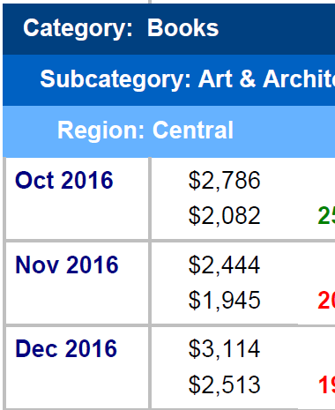

**Solution –**

* Create fisrt parent group
* Add child attributes

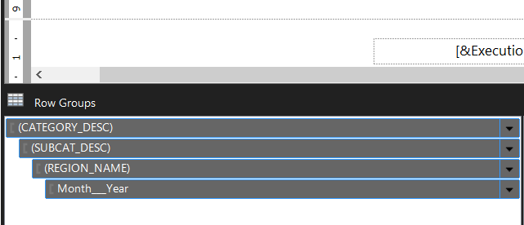

1. **Quarter- Year Attribute only for Q4 2016**

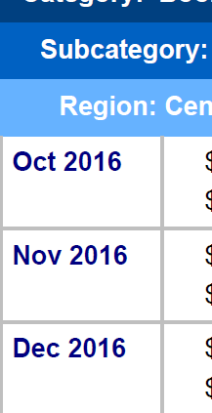

**Solution –**

* Whiile improting dataset we have to apply filter condition for Q4 2016

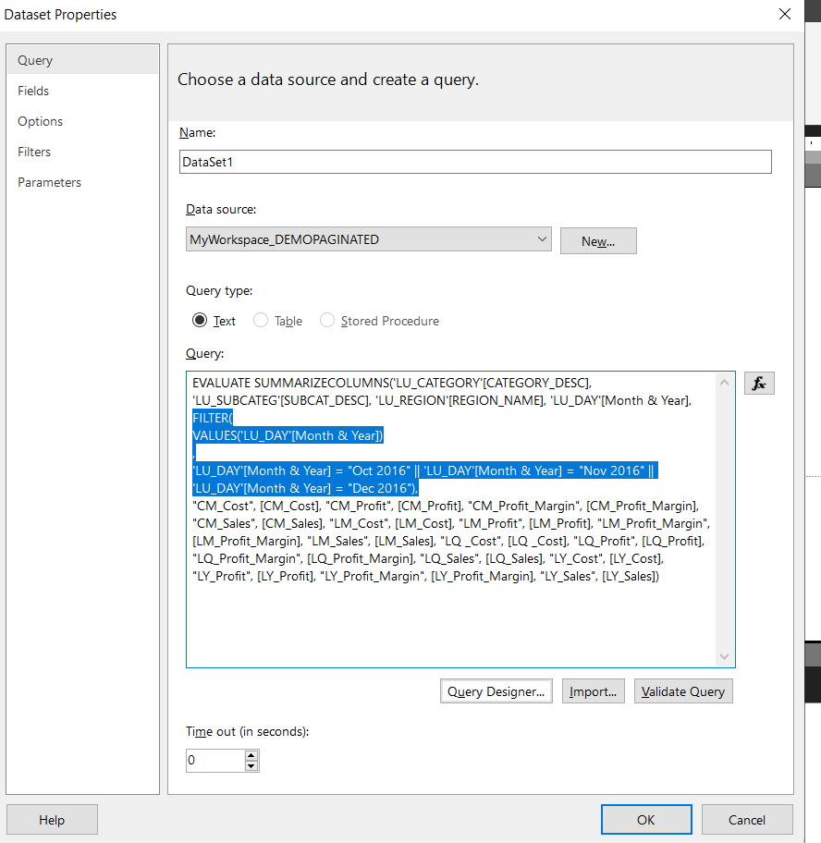

* Another One option is there getting this output but using this method we cant get correct value for total sales for quartely.(It gives for all months)
* Row Group select Month& year right click

Group properties > filter > add condition for only Q4 2016

1. **Four Measures in a single column**

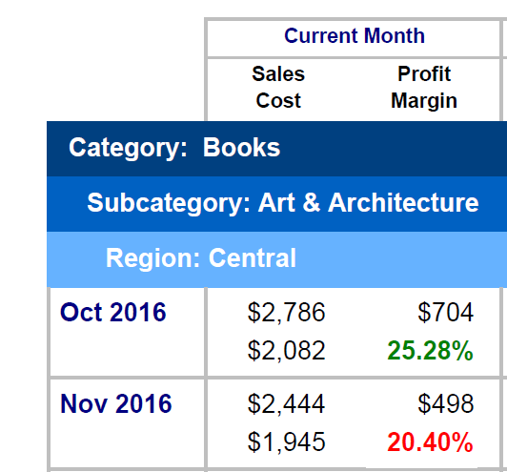

**Solution –**

* Right click on box and insert row inside group - Below

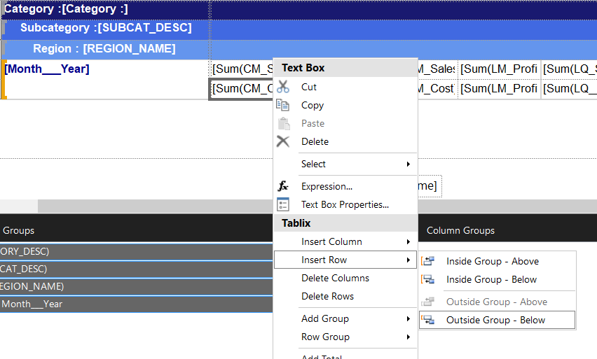

1. **Finding out formating criteria**

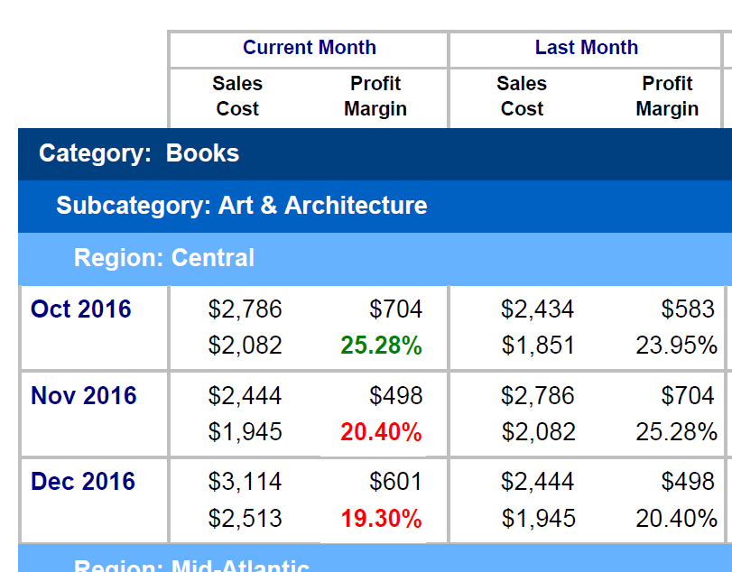

**Solution –**

* CM Margin > LM Margin then margin color is GREEN
* CM Margin < LM Margin then margin color is RED
* Select Margin Box and right click,

Select Text box Expression > font > add formatting condition

* DAX = IIf(Fields!CM_Profit_Margin.Value < Fields!LM_Profit_Margin.Value, "Red", "Green")

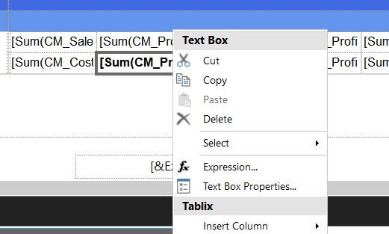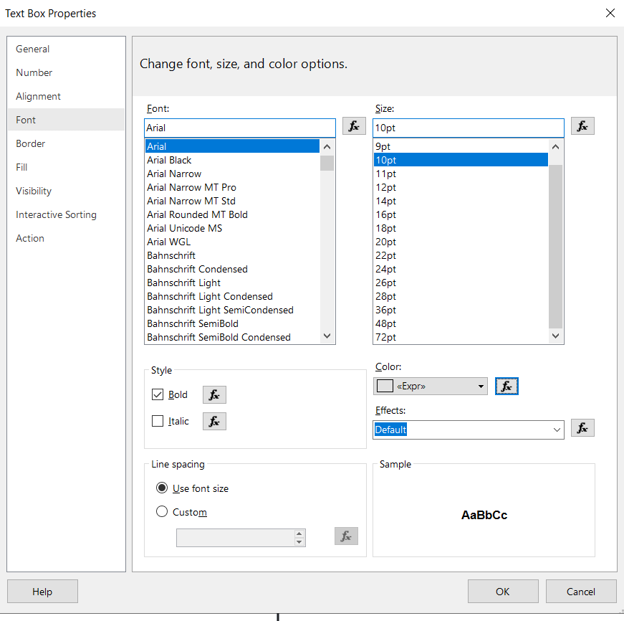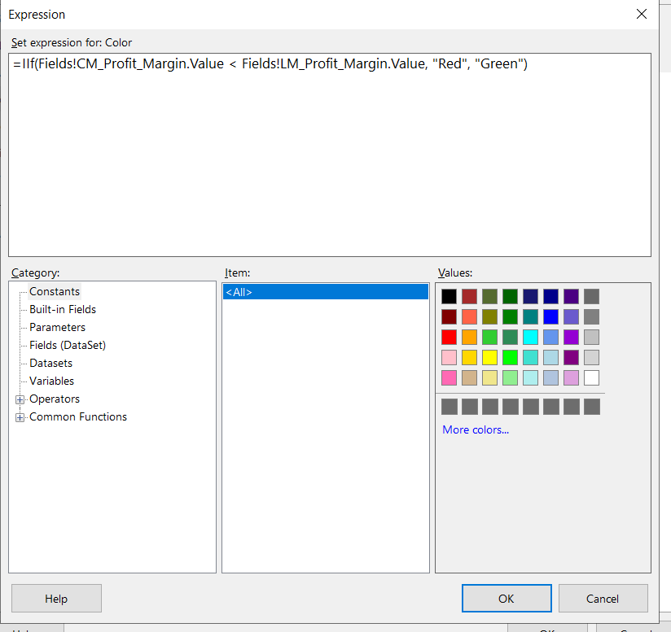

1. **Quarter sales**

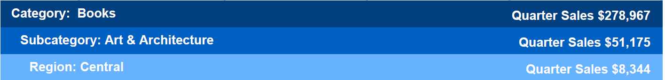

Solution –

While importing Dataset

* Apply filter condition on region (Region id -1,2,3,4,5,6,7) &
* month – year(Oct 2016, Nov 2016, Dec 2016)

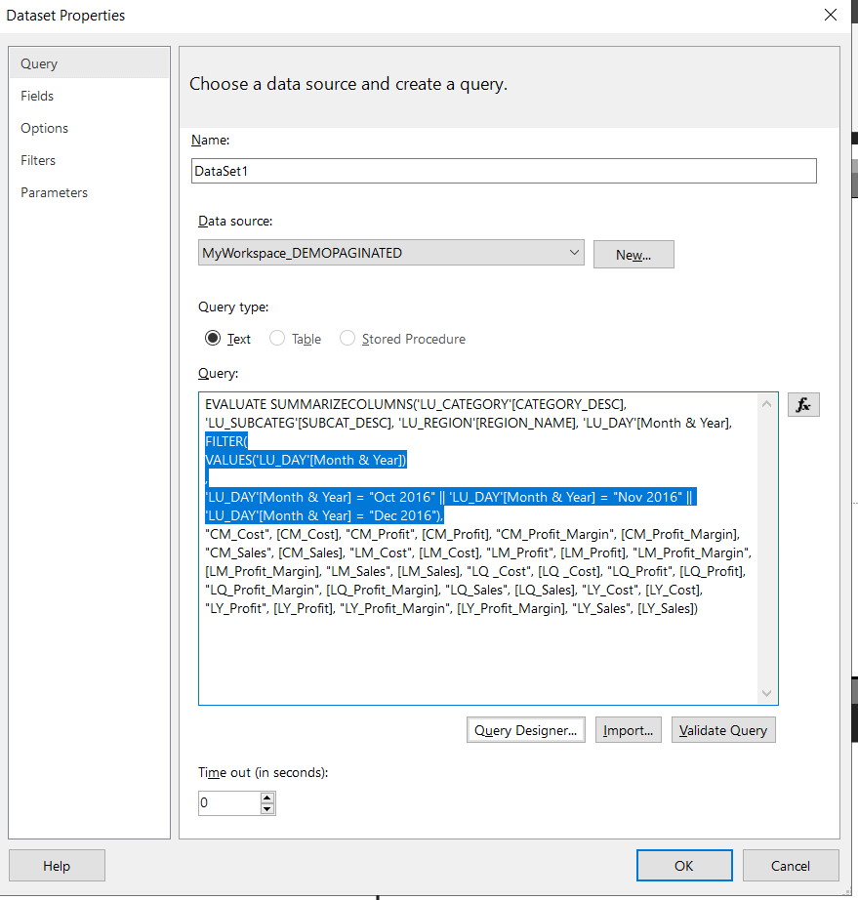

* Add CM Sales

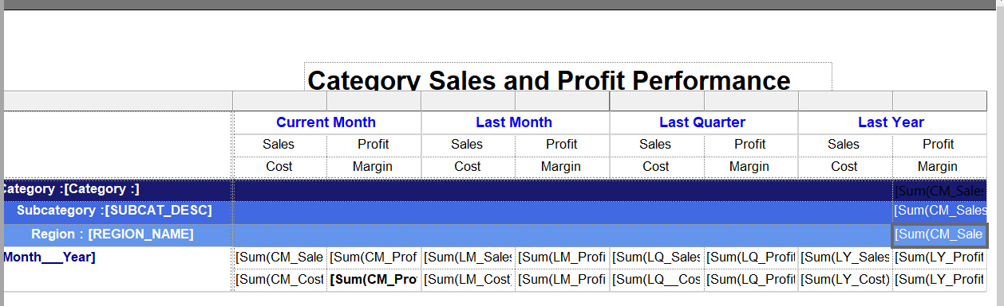

1. Cascadind Parameters



References - https://www.youtube.com/watch?v=WSEYAIc5vfs&list=PLjNd3r1KLjQs-JsZ-PSb6gBKWu7F9GtPZ&index=1